MEASURING DM ATTENUATION of YOUR CMC USING THE NANOVNA AND NANOVNA SAVER
WØLEV 29 January, 2021

The following procedure outlines a set of steps aimed at accomplishing a specific goal, that of measuring the DM loss through a CMC as a function of frequency. It is by no means or stretch of the imagination meant as a basic tutorial addressing “The Care and Feeding of a Vector Network Analyzer”. There are plenty of excellent tutorials on that subject in the Wiki, some of which I have repeatedly posted to the group. The online tutorial from Agilent is excellent, but will require some math. An understanding of basic VNA technology and a working knowledge of NANOVNA SAVER is assumed in execution of the following procedure.

A VNA is not a DMM, oscilloscope, or a spectrum analyzer. To fully appreciate the power of a VNA in the RF world, a working knowledge of algebra and trigonometry is highly desirable. Some of the theory behind the measurements it is capable of making involve higher math, including calculus. Don’t let that scare you! I will strive to keep any and all math to an absolute minimum. So……., lets dig in.

This procedure will measure the DM loss (the energy you want to/from the antenna) through the respective CMC while embedded in a 50-ohm system. This procedure is centered around use of the NANOVNA H4 model, but the procedure should apply to any of the NANOVNA instruments and is pretty much identical to what I used with the HP 8753C except for NANO and SAVER specific operations. The following procedure is also applicable to measurement of other 2-terminal transmissive devices like filters, attenuators, active stages, and….. However, when applied to frequencies above 50 MHz, good RF connectors that are impedance controlled should be used. Note the popular SO-239 and PL-259 are NOT impedance controlled connectors, but if you have them in your system as interconnection to/from the antenna feedline/CMC, use and calibrate with them in place.

- Connect the NANO to the PC supporting SAVER with the appropriate USB cable.
- Turn on the NANO.
- Launch SAVER.
- Establish connection between the NANO and SAVER.
- If the NANO is sweeping on initiation of connection, click on STOP.
- Set the frequency start to 0.5 MHz.
- Set the frequency stop to 52 MHz.
- Set the “SEGMENTS” to 10.
- Under sweep settings, set to Single Sweep. Then close that box.

Here is a picture of my setup ready for calibration using my interface connectors. Yours may vary based on your interface connectors. Use connectors common to your specific setup for the calibration. I use parallel conductor transmission to/from the 450-foot long doublet. Banana plugs/jacks are convenient for that application and perform well at HF frequencies. Never mind the adaptors to get from SMA to BNC and the banana jacks. Above 50 MHz, banana plugs/jacks are not appropriate.
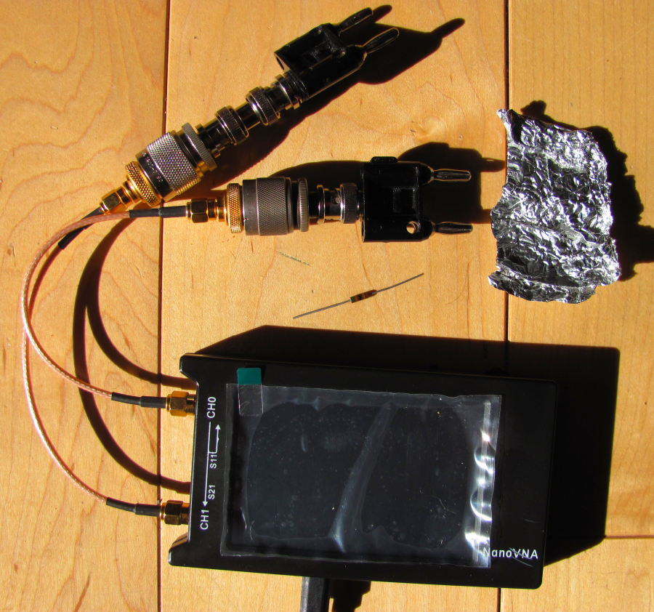
- Launch “CALIBRATION”.
- In the CALIBRATION box, launch “CALIBRATION ASSISTANT”.
- Perform a complete cal. (SOLThur using your standards and cables per the on-screen prompts. Be sure to include the adaptors necessary to connect to your CMCs to the NANO in the cal.
NOTE: My cal standards for the banana plugs/jacks are:

OPEN: Obvious…..open
SHORT: Aluminum foil held firmingly against the prongs connected to Channel 0
LOAD: 51-ohm ¼-watt Carbon Resistor

FURTHER NOTE: If you are concerned about the slight amount of inductance (+jX)
the resistor leads add, consider that #18 wire has an insuctance of
18.1 nH / inch. Give it 20 nH / inch and a total length (including the
resistor) of 2-inches, that amounts to adding an series inductor of
40 nH to the cal standard. At 1.9 MHz that amounts to +j 0.478
ohms. At 30 MHz, that amounts to +j 7.54 ohms. So on 1.9 MHz, the
additional +jX is insignificant. At 30 MHz the ‘standard’ rotates
upward on the 50-ohm circle 7.54 ohms worth. You can pretty much
eliminate the inductance of the leads by connecting the resistor with
‘leads’ of 1-inch wide copper tape. If it upsets you as a standard,
find a better standard for 30 MHz that interfaces with banana plugs.
For my purposes I’m satisfied with the small error.
- Once the cal. Is complete, store it in a file under SAVER (a folder you create) for future reference.
- Click on APPLY in the SAVER window.
- You are now ready to begin the measurement of DM loss through your CMC in a 50-ohm system, so connect the CMC with the cables and adaptors you used in the cal.
- Access the “SWEEP SETTINGS” window again and set the SWEEP to continuous.

Following is a picture of the setup ready for measurement:
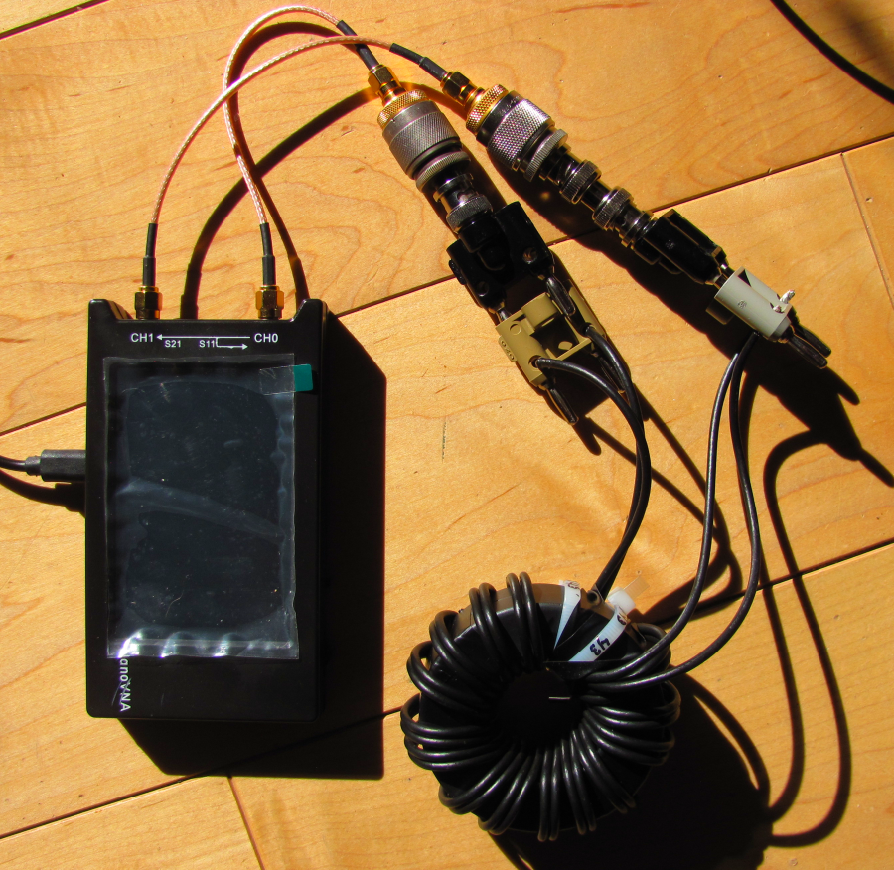

- Initiate the SWEEP by clicking on that box in the SAVER window.
- Wait for the sweep to complete – this may take a couple a minute or so.

Following is the completed sweep as rendered in SAVER. The CMC I have chosen is the 300-43
2-stacked toroids wound with 16 bifilar windings using the DavisRF #14 Flex-Weave conductor. This CMC has previously been measured on the HP 8753C setup, so at the end, I will list both the NANOVNA/SAVER measured values and the HP equipment measurements.
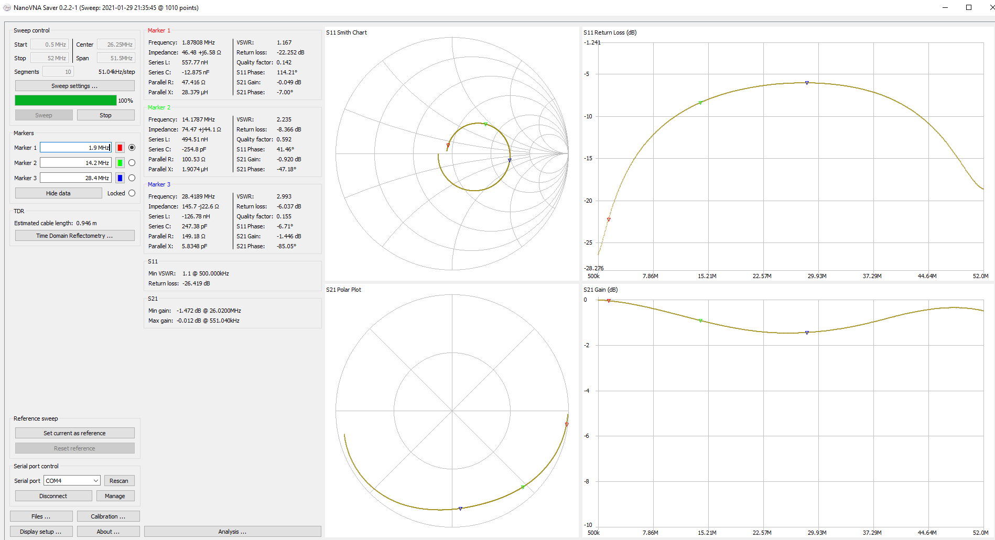
- In the SAVER window under MARKER (red, green, blue) set the frequency(ies) you want to measure. Be sure to enter the units, Hz, KHz, MHz, or GHz.
- In the box to the right of MARKER in the SAVER window toward the bottom of the right-hand column of each marker read the loss in dB. I’ve placed the markers at 1.9, 14.2, and 28.4 MHz, the same as I used with the HP equipment.

Tabulation of the complete data taken with both the NANO and the HP equipment follows:

BAND FREQUENCY (MHz) NANO (dB) HP 8753C (dB)

160 Meters 1.90 -0.049 -0.05
75/80 Meters 3.75 -0.13 -0.09
40 Meters 7.15 -0.34 -0.29
30 Meters 10.1 -0.58 -0.80
20 Meters 14.2 -0.92 -1.20
17 Meters 18.1 -1.21 -1.60
15 Meters 21.3 -1.38 -1.30
10 Meters 28.4 -1.45 -1.20

Considering measurements were made a week apart using different cal. standards, the agreement is rather good. Remember, my standard for 50-ohms used with the NANO for these measurements is certainly not as good as the HP standard load.

TERMS:
CMC: Common Mode Choke
CM: Common Mode (as with coaxial transmission line)
DM: Differential Mode (as with parallel conductor transmission line)

